**What we have done last week:**

Meeting with the client and get the priority list of items we should have on the milestone ([priority list](https://drive.google.com/a/miamioh.edu/open?id=14W38W76lILDyMHFdHX2-E2HW-Ql3V1hL865JyAsO6_I)).

**What we are doing since the last week:**

Two groups:

Group 1: collect all items data (i.e. position of shelves, area of computers), particularly, the call numbers of books stored in King Library ([sample data](https://drive.google.com/a/miamioh.edu/open?id=1vhjhypjFvwf1LY1FxxovLBBCeN4QQWkBN2nxrwS5Y1g)).

Group 2: transfer 2D library map into a usable data structure. For instance, we are finding a tool to create a coordinate axis based on the [precise map](https://drive.google.com/drive/u/1/folders/16JfdvRwgpPZ_eCXvlo4E7C3CZSSVr5xN) or using the HTML vector to build data.

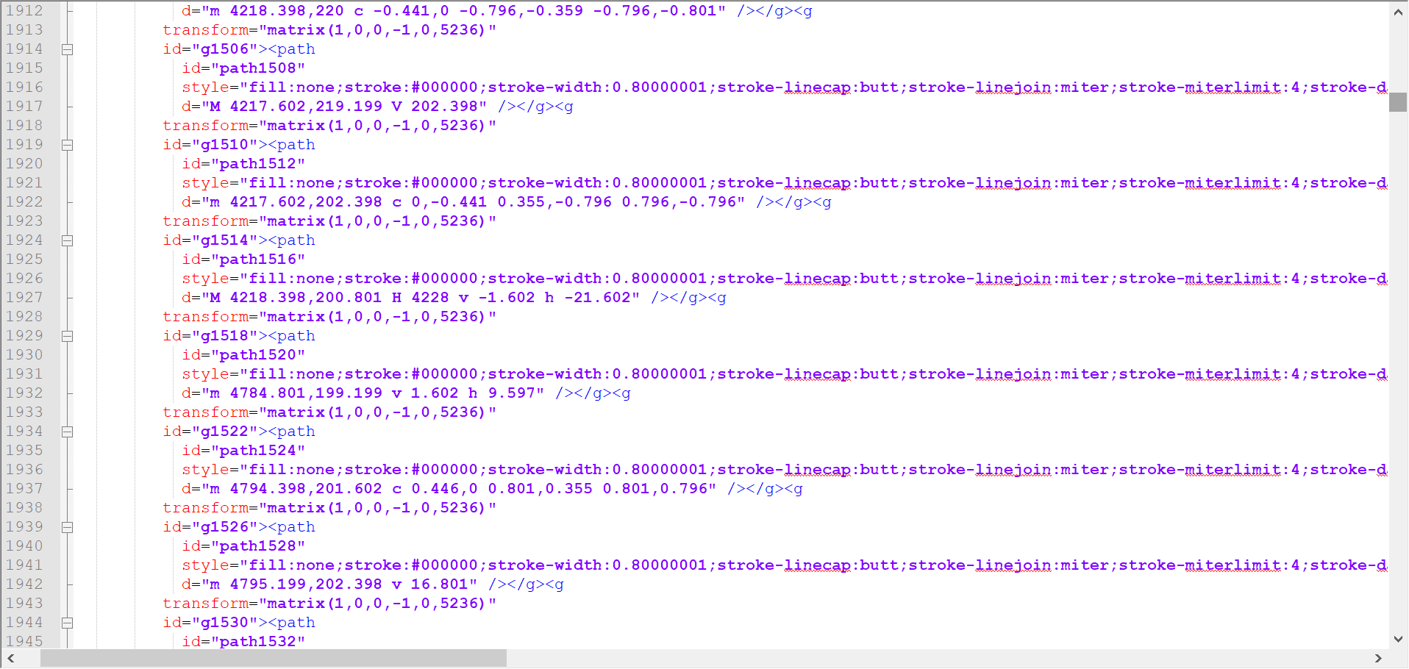

**What will be done next week:**

Group 1: Data collecting (the book’s information)

**Conclusion:**

The most important task for our group is to collect and create useful data before the implementation of the application, such as a map made by vertices and edges, a book with basic information and call numbers.